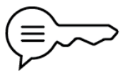
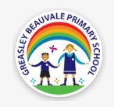

RE - What does it mean to be a Muslim in Britain today?
Muslim | A follower of the religion of Islam, someone who submits to the will of Allah | Salah | Compulsory daily prayer for Muslims, the second of the Five Pillars
Ibadah | The word for worship in Arabic | Sawm | Fasting during the holy month of Ramadan, the third of the Five Pillars
Submission | Accepting a superior force and doing what they want | Zakah | Compulsory giving of charity every year, the fourth of the Five Pillars
Ramadan | The month in the Muslim calendar when those who can fast do so | Hajj | The pilgrimage to Makkah during the month of Dhul Hijjah that all Muslims should make during their lives if they can, the final of the Five Pillars
Shahadah | The basic statement of belief for Muslims; the first of the Five Pillars | Pilgrimage | A journey taken for religious reasons
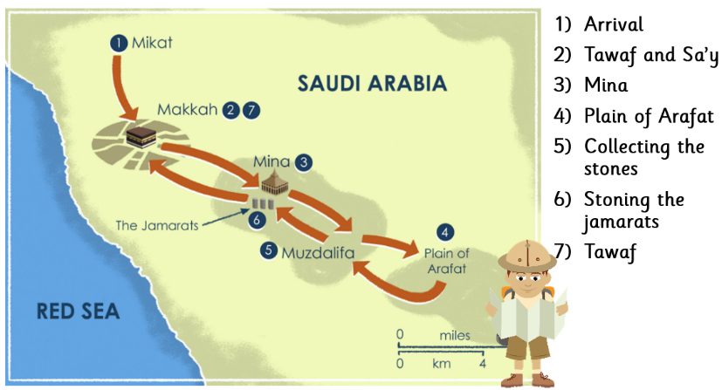
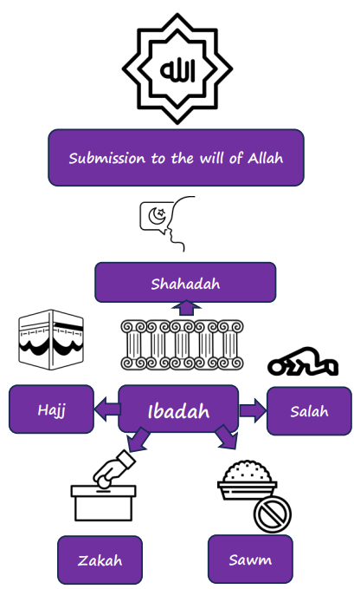
Sticky knowledge
The Hajj
- Approximately 24% of the world’s population would call themselves a Muslim
- Approximately 7% of the population of England and Wales would call themselves a Muslim
- Many Muslims will perform five activities that show they worship Allah, this is known as ibadah or worship.
- The five activities are known as the Five Pillars of Islam.

