

Science – Earth and Space (Autumn 2)
Sun | a huge star that the Earth and other planets orbit around | spherical | shaped like a sphere | Geocentric model | a belief that the Sun and all other planets orbit around a stationary Earth
star | a celestial body,made of gas that shines by its own light. | celestial | an object in the sky beyond earths atmosphere | Heliocentric model | a belief that the Sun is stationary and all other plantes orbit around it.
moon | a celestial body which orbits a planet | rotate | to spin, keeping in one place | crescent | the curved shape of the moon
planet | a large object that orbits a star | axis | an imaningnery line that a planet rotates around | orbit | to move in a regular, reapting pattner around an object


Our sun, Earth and moon are approximately spherical bodies.

Our solar system has eight planets which orbit the sun.

Earth rotates on its axis. It does a full rotation once in every 24 hours. We get day and night because different parts of the planet are facing towards the sun or away from it.

It appears to us that the sun moves across the sky during the day but the sun does not move at all, it is the Earth that is moving.
Sticky Knowledge
Earth has one moon. The moon orbits Earth in an oval- shaped path while spinning on its axis.
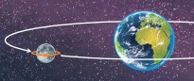
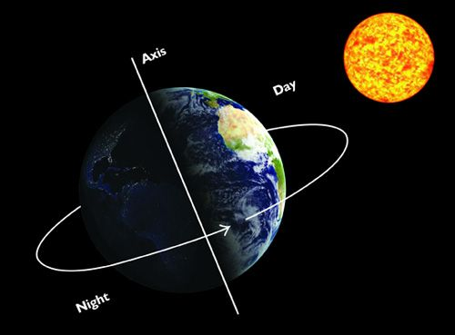
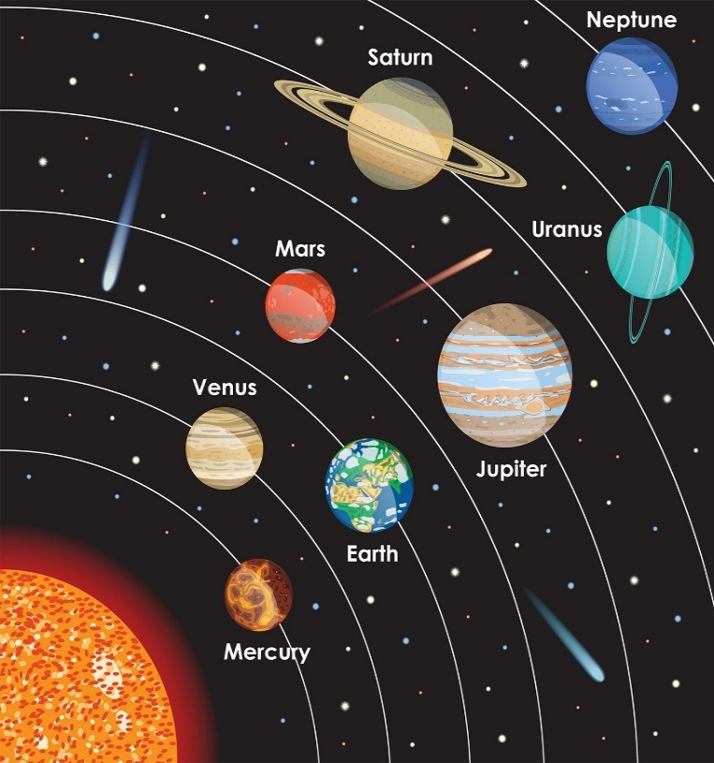

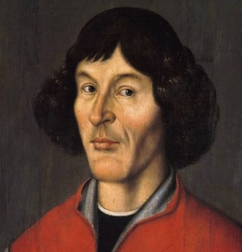
Years ago people believed that planets moved around the Earth. Nicolaus Copernicus was an astronomer who developed a model

that placed the sun

rather than Earth at

the centre of the

solar system.


