Holy | God is  morally pure and hates sin
Omnipresent | God is everywhere
Omniscient | God is all knowing
Believer | a person who believes and accepts the truth of something
Eternal | God created time and is not limited by it – God is outside time
Loving | God is kind and forgiving.
Omnipotent | God is all powerful
Isaiah | An Old Testament prophet who speaks of the power and holiness of God
John | A letter written a few years after the death of Jesus, which is believed to be by one of the disciples
Testament | A statement of belief; one of the two sections of the Christian Bible


What does it mean if Christians believe God is holy and loving?
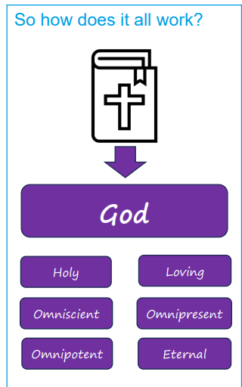
God is described as omnipresent, this means that God is everywhere because he is eternal and is outside time. God is also described as omniscient, this means he knows everything.
The book of the prophet Isaiah in the Old Testament talks about his experience of God. He talks about how God is holy and powerful. For Christians, God is omnipotent, which means he is all powerful, for example as the Creator in the book of Genesis.
Christians use the Bible to explore what God is like, reading many different books in the Old Testament and the New Testament to understand better the nature of God.

