
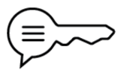
Art – Lui Ferreyra
Self-portrait | A painting, drawing, photo, or sculpture that artists make of themselves. | Hatching | Drawing lots of close parallel lines. | Texture | The surface quality of a piece of art. It is how an object actually feels when touched, or how it looks like it would feel.
Mood | The feeling or atmosphere that a piece of art gives to the person looking at it. | Cross-hatching | Crossing lines over each other to make areas darker. | Expression | Showing feelings, moods, or ideas through art.
Shading | A darker version of a colour or a dark area on a drawing. | Blending | Smuding pencil or paint smoothly. | Tone | How light or dark a colour, shade or object is.
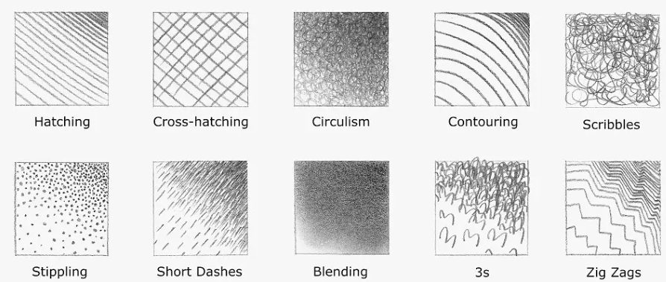
Sticky knowledge
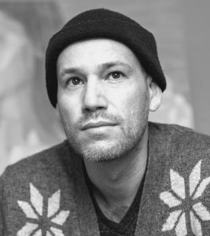
Lui Ferreyra is an artist from Mexico who creates detailed pencil drawings, paintings, nature scenes inspired by the mountains of Colorado, and portraits of people. He uses different art styles, including pointillism, and encourages people to use their imagination to complete his pictures in their minds.



