
Science: Forces
Strand: Physics
Year 3  (What should I already know?) | Year 5  (What will I know by the end?) | KS3  (What will I learn next?)
- Compare how things move on different surfaces.  - Notice that some forces need contact between two objects, but magnetic forces can act at a distance.  - Observe how magnets attract or repel each other and attract some materials and not others.  - Compare and group together a variety of everyday materials based on whether they are attracted to a magnet and identify some magnetic materials.  - Describe magnets as having two poles.  - Predict whether two magnets will attract or repel each other, depending on which poles are facing. | - Explain that unsupported objects fall towards the Earth because of the force of gravity acting between the Earth and the falling object.  - Identify the effects of air resistance, water resistance and friction that act between moving surfaces.  - Recognise that some mechanisms, including levers, pulleys and gears, allow a smaller force to have a greater effect. | - Forces as pushes or pulls, arising from the interaction between two objects.  - Using force arrows in diagrams, adding forces in one dimension, balanced and unbalanced forces.  - Moment as the turning effect of a force.  - Forces: associated with deforming objects; stretching and squashing – springs; with rubbing and friction between surfaces, with pushing things out of the way; resistance to motion of air and water.  - Forces measured in Newtons, measurements of stretch or compression as force is changed.
Wonder and curiosity
Key Values:
Vocabulary
Force | Changes the motion of an object. Pushes and pulls in a particular direction. | Water resistance | Type of force that uses friction to slow things down that are moving through water.
Gravity | A force that exists everywhere and pulls all things with mass or energy toward one another. It was discovered by Sir Isaac Newton. | Resistance | A force between surfaces that are touching.
Gravity |  | Streamlined | Shaped to minimise the effects of air or water resistance.
Gravitational pull | Pull that Earth exerts on an object pulling it towards the Earth’s centre. | Levers | Helps us to lift objects. It is supported by a fulcrum, which is where the arm pivots.
Weight | The measure of the force of gravity on an object. | Pulleys | A simple machine which makes it easier to lift or move a heavy object.
Mass | A measure of how much matter (stuff) is inside an object. | Gears | Wheels with teeth that slot together. When one turns, the others do as well. If different sizes are used, they can be used to increase the power of a turning force.
Air resistance | Resistance or drag, acts against gravity on falling objects. | Gears
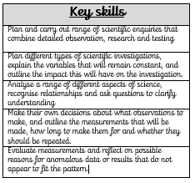
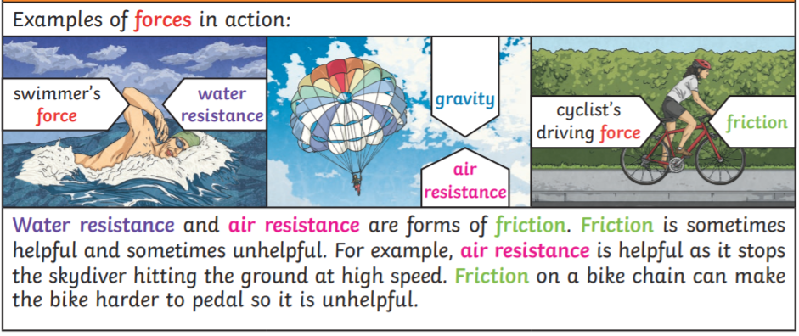
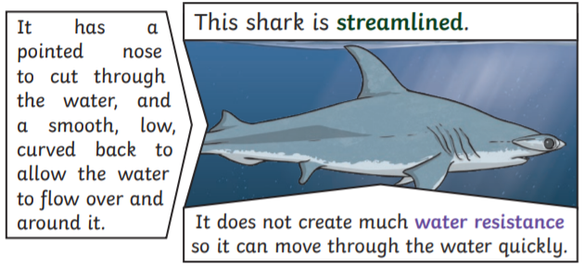
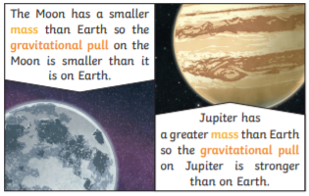
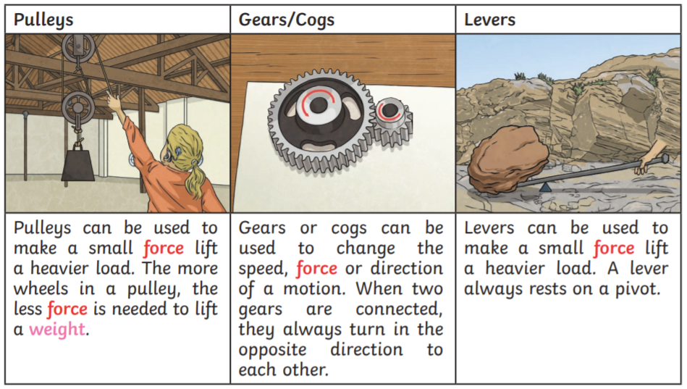
Sticky knowledge
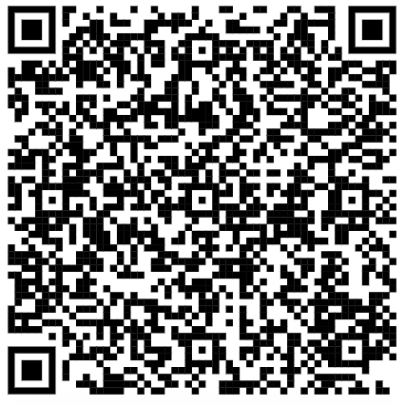
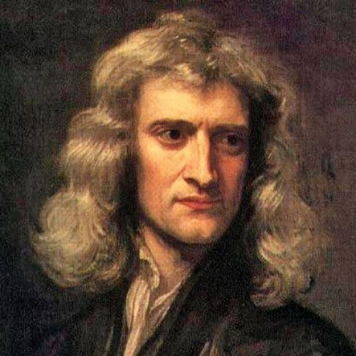
Sir Isaac Newton - born in 1643
Best known for 'discovering' gravity, but he worked on so many different topics that our understanding of the world was changed forever by his work. He had many roles in his life beyond his scientific research: he was Warden and Master of the Mint, and President of The Royal Society, as well as a member of parliament (MP). He discovered that white light is made up of a range of colours. described gravity as a pulling force that keeps people on the ground rather than floating off. He also noted that gravity keeps the moon in orbit. Newton told the story of seeing an apple fall to the ground from a tree which inspired him to wonder why it fell down, rather than up or across.

"If I have seen further, it is by standing on the shoulders of giants."

