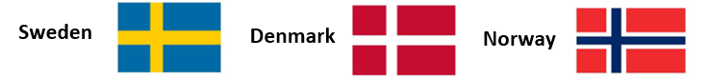

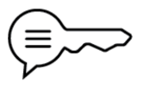
Anglo-Saxons and Vikings (Autumn 2)
Angles | a tribe from Europe that settled in Britain | Saxons | a tribe from Europe that settled in Britain | kingdom | an area of land that is ruled by a king or queen
Christianity | the religion which follows the teachings of Jesus Christ | tribe | A group of people who live together and share a way of life. | invasion | invading a country or region with an armed force
primary source | original first-hand accounts of or objects from an event, topic or historical time period | secondary source | a second-hand account that interprets primary sources | Viking | a person from Scandinavia who raided countries across the sea
monastery | buildings occupied by a community of monks living under religious vows | migration | to move from one place to another | agriculture | the practice of growing crops or raising animals
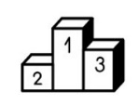
Sticky knowledge
Timeline
410 | 497 | 575 | 586 | 597 | 757 | 793 | 871 | 1016 | 1066
Romans left Britain leaving it unguarded | The kingdom of Wessex is formed | The kingdom of East Anglia was formed | The Kingdom of Mercia is formed | St Augustine introduces Christianity | 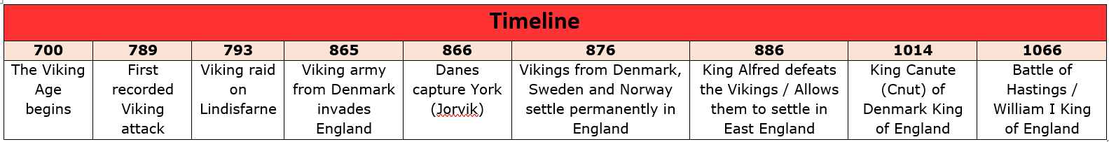  Offa King of Mercia declares himself King of England | Vikings attack Lindisfarne | Alfred the Great rules | Canute the Great rules as first Viking | Battle of Hastings Normans defeat the Saxons

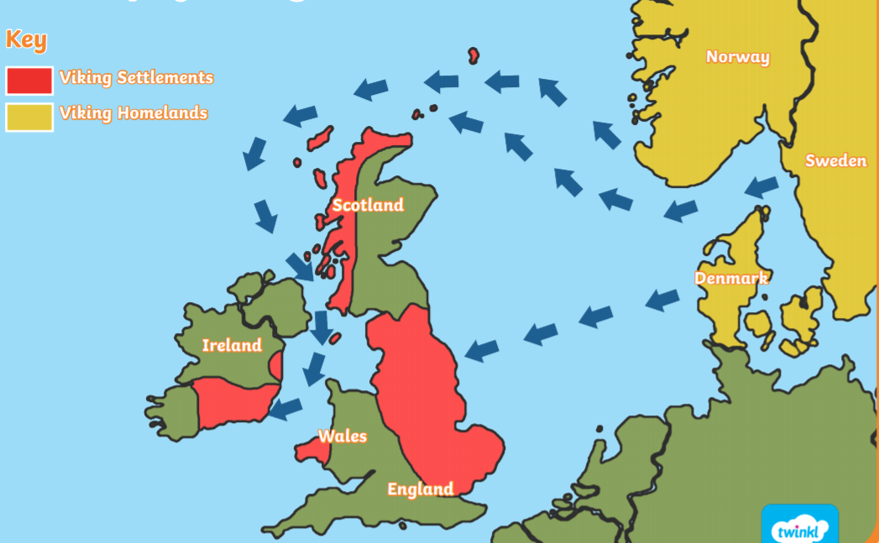
The Vikings
The Vikings came from countries called Norway, Denmark and Sweden, and the Anglo-Saxons already lived in Britain when they arrived. The two groups often fought each other because both wanted land and power, but the Vikings won many battles as they had strong ships and were fierce fighters.

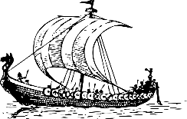
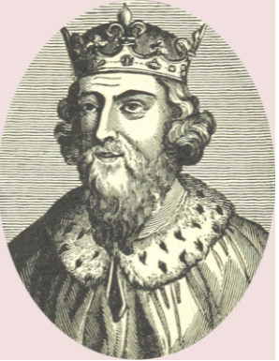
King Alfred the Great was the best known Anglo-Saxon king and the first to defeat the Vikings in battle.

