chemical changes | a change where a new material is made. You cannot change it back. Example: baking a cake. | physical changes | a change where the material stays the same, just looks different. You can often change it back. Example: ice melting into water.
solution | a mixture made when something has dissolved in a liquid | filter | a device used to remove dirt or other solids from liquids
property | a quality or feature of a material (like hard, soft, waterproof) | combine | to mix things together.
seperate | to take a mixture apart into its different parts | dissolve | when a solid mixes into a liquid and seems to disappear
soluble | able to be dissolved | insulator | a material that does not let electricity or heat pass through easily
insoluble | unable to be dissolved | reversible | can be changed back to its original form
conductor | a substance that heat or electricity can pass through easily | reaction | what happens when substances change, often making something new
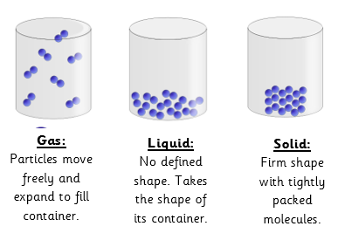

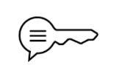
Sticky knowledge
Science – Properties of Materials (Summer 1)
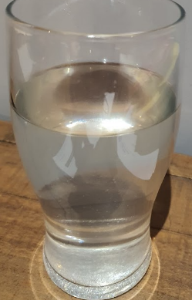
Reversible changes, such as dissolving, can be reversed by:
Dissolving

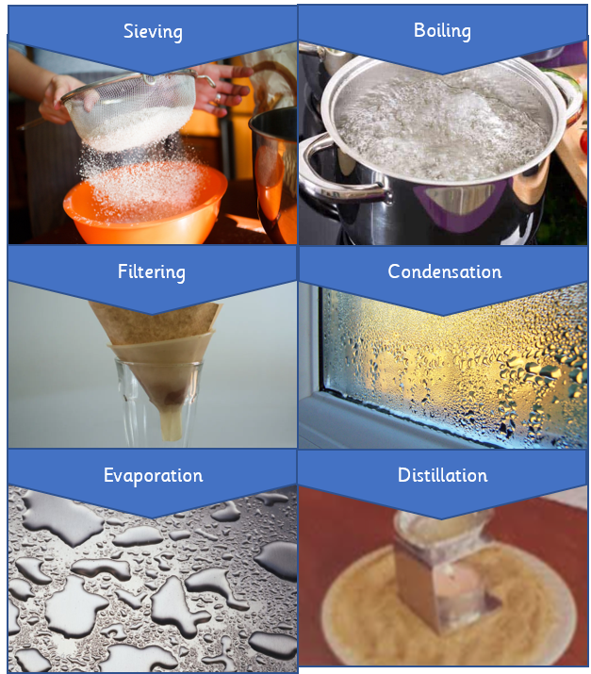
Two substances becoming one solution.

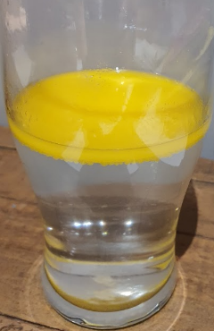
Irreversible changes
Melting
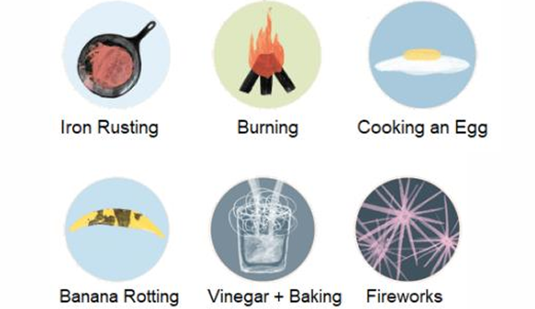
Changes state but does not mix.

