cause | factors that lead to an event | military | the armed forces (army, navy, air force) | civilian | people not part of the armed-forces
air raid | an attack by enemy aircraft, usually dropping bombs | Anderson shelter | a small metal shelter to protect people during bomb attacks | conscription | a process where civilians were called for compulsory service
primary source | something created during an event that gives first-hand information | coal | a black rock that can be burned to make heat or electricity | mining | the job of digging into the ground to find and remove natural resources
evacuation | a relocation of people from cities to rural areas | rationing | a system to fairly shared limited food and other goods | Holocaust | the torture and murder of approximately six million Jews by the Nazis
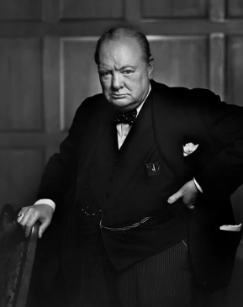
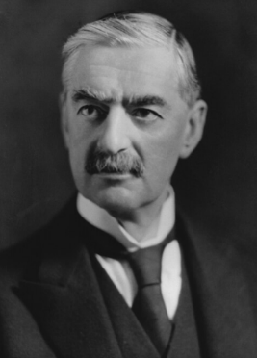
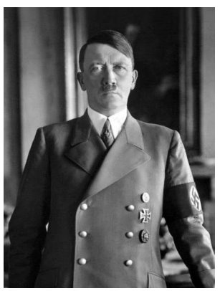

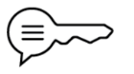
World War II in Our Local Area
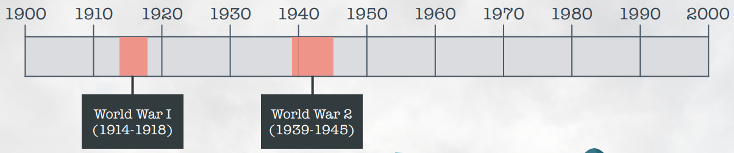
World War II was the second global war of the 20th century.

Eastwood
During World War II, Eastwood was a coal mining town. Many civilians were conscripted to work in the mines to to increase the rate of coal production. Coal from local mines powered trains, ships and nearby factories that made weapons and supplies.
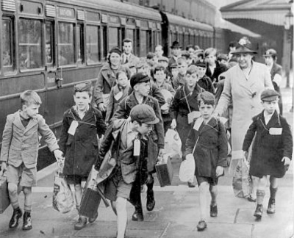
Children were
evacuated from
big cities,
like
Nottingham,
to safer more
rural areas.

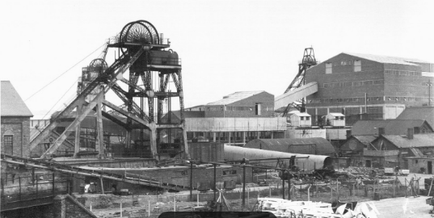
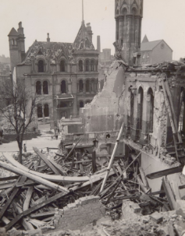
On the nights of May 8th
and 9th, 1941,
Nottingham faced an
air-raid attack. The historic
caves below the city made
ideal air-raid shelters.
Winston Churchill (Prime minister of Britain 1940 - 1945)
Neville Chamberlain (Prime minister of Britain 1937 – 1940)
Adolf Hitler (Leader of the Nazis 1933 – 1945)

