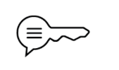
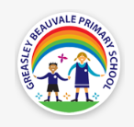
Science: Light
Key Vocabulary
Light | A type of energy that makes it possible for us to see | Opaque | An opaque material does not let light through. It does not reflect light. | Shadow | The shape that is formed when light is blocked
Source of light | The sun and other stars, fires, torches and lamps are all examples of light sources | Translucent | A translucent material lets light pass through, but objects on the other side can’t be seen clearly. | The law of reflection | The law states that the angle of incidence is equal to the angle of the reflected ray
Visible spectrum | The range of colours we can see with our eyes | Transparent | Transparent materials allow you to see through them clearly. | Reflection | How the light behaves when it reaches a surface
Prism | A 3D shape that allows us to see the visible spectrum | Refraction | The bending of light as it passes from one substance to another


